Railway Operations Class
David B. Clarke, University of Tennessee, Knoxville and Dimitris Rizos, University of South Carolina

Increasing the number and diversity of rail focused courses is an important step in rebuilding America’s railway education infrastructure. Currently, most college level rail courses are on railway civil engineering topics. A new course jointly developed by the Universities of Tennessee and South Carolina addresses railway operations. Providing engineering students with a better understanding of operations can improve infrastructure design and maintenance practices. The course also attracts business students interested in a career in railway management.

Overview
Rebuilding America’s college based railway education programs is an important step in addressing projected railroad workforce needs. A large percentage of the current professional workforce will retire in the next decade. College programs in railway transportation can play an important role is preparing their replacements.
The important fields of railway operations and management are underrepresented in American universities. Departments of business have moved away from railway specific courses in favor of a supply chain management approach that deals little with individual transport modes. Yet experienced railroad operating managers are retiring, and replacing this knowledge base is essential for the industry’s health. Future railway managers will benefit from coursework in operations. In addition, exposure to operating principles provides insight for engineers involved in line, terminal, and facility design.

Course Goals
The authors began initial discussions relating to the development of a one semester rail operations class following the 2012 Railway Engineering Education Seminar (REES). Dr. Rizos felt that the class would be a useful addition to his railway engineering course offerings at the University of South Carolina (USC) Dr. Clarke felt similarly that the course could draw both engineering and business students at the University of Tennessee, Knoxville (UTK).
The course goal was to present basic operating principles of North American freight and passenger railroading, including shared access corridors handling both services. The identified course topics were:
- Vehicle technologies
- Infrastructure
- Train performance
- Signaling and control
- Freight services
- Passenger services
- Service design
- Capacity
- Rolling stock management
- Labor requirements/management
- Terminal operations
- Safety and security
- Railway management and administration
Content would address operating differences based on railroad size or market (e.g., intercity passenger versus commuter rail, Class 1 freight railroad versus Class 3 short line). Students would not need prior railroad knowledge. However, they should have upper class or graduate standing.

Content Development
Investigation failed to uncover existing course materials or modern college level textbooks on North American railroad operations. While there are texts that contain useful subject material, no single source was deemed sufficient and purchasing multiple books is expensive for students.
Accordingly, the instructional team elected to develop a series of PowerPoint slide presentations to serve as student lecture notes. Sets of slides address each of the major course topic areas. Students view the slides during the lecture, and may download them after class.
The instructional team felt that slides were insufficient to fully explain the complexities of railroad operations. With railroads being sensitive about releasing detailed operating information, the team elected to create a hypothetical railroad for the class. Thus was born the Piedmont Western System (PWS), a 920 mile freight carrier with a network of routes. Students receive detailed information on the railroad’s infrastructure, terminals, rolling stock, employees, customer base, and traffic patterns. Example resources include operating rules, employee timetables, facilities guides, yard diagrams, labor agreements, station/customer lists, and traffic data sets. These materials help students address operating questions in the same manner as in an actual railroad.
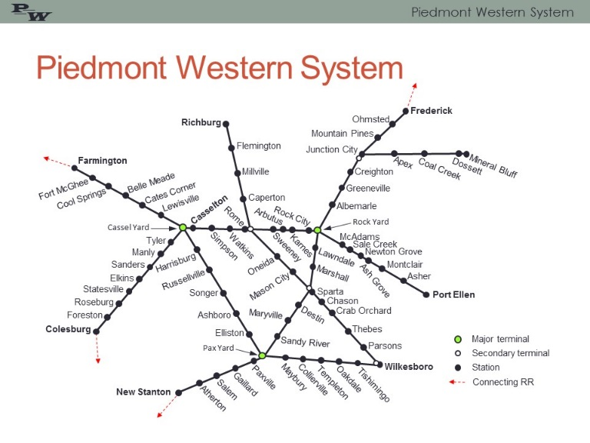Map showing hypothetical PWS railroad used for class
The course content includes a series of traditional homework assignments. Some of these call for analysis of operating issues or problems with the hypothetical railroad. Others address material in the assigned readings. There are three written exams, each intended to cover approximately one-third of the course.

Course Delivery
Presently, students attend the course in a campus studio at USC. The instructor normally uses Adobe Connect and an internet connection to deliver the lecture and presentation. This is normally live, with one-way video (instructor to student), and students may ask questions during the lecture. To provide better interaction, the instructor meets with the students several times during the semester.
Students receive materials via the course Blackboard site. Blackboard also provides links to other relevant internet resources, announcements, email, and other resources. Homework is submitted using Blackboard or email.
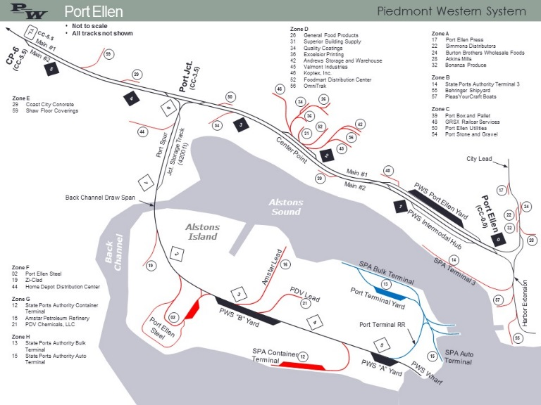Page from PWS Facility Guide

Future Steps
After two offerings, student evaluations of the class are positive. Yet, the instruction team continues to consider ideas for improving the learning experience.
One intriguing idea is to incorporate client-server based railroad simulation software into the course. The instructors have located inexpensive commercial software that reflects two actual railroad territories. Using this software, students could work as a team to conduct operations in one of the territories. However, instructors would need to adjust existing course content and students would be required to purchase individual copies of the software.
The instruction team definitely plans to continue developing and improving the materials for the hypothetical PWS railroad. The PWS demonstrates well the concepts of large network oriented railway companies, yet at scale appropriate for instruction.

