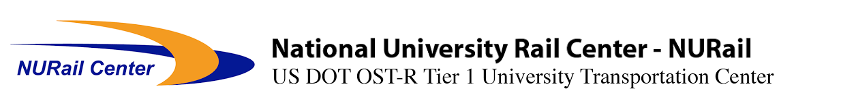
AREMA Educational Foundation
2016 Scholarship Winners

Kelsey Abbott
Michigan Technological University
Michigan Tech Alumni Scholarship
Otto Freiberg
Michigan Technological University
Michigan Tech Alumni Scholarship
Phanuwat Kaewpanya
University of Illinois at Urbana-Champaign
Committee 4 - Rail Art Worth
Memorial Scholarship
Frederick Bradford Kippen, III
University of Illinois at Urbana-Champaign
Committee 4 - Rail Art Worth
Memorial Scholarship
Alexandra Lakenen
Michigan Technological University
Michigan Tech Alumni Scholarship
Chen-Yu Lin
University of Illinois at Urbana-Champaign
Larry L. Etherton Scholarship
Xiao Lin
University of Illinois at Urbana-Champaign
Norfolk Southern Foundation Scholarship
Alexander Lovett
University of Illinois at Urbana-Champaign
Committee 27 – Maintenance-of-Way Work Equipment Scholarship
Vassilios Lygiros
University of Illinois at Urbana-Champaign
New York Central Railroad
Memorial Scholarship
Darkhan Mussanov
University of Illinois at Urbana-Champaign
Committee 14 - Yards & Terminals Scholarship
Derek Owen
Michigan Technological University
Committee 18 - Light Density & Short Line Railways Scholarship
Sean Pengelly
University of Illinois at Urbana-Champaign
Committee 24 - Education & Training Scholarship
Allison Phillips
Rose-Hulman Institute of Technology
AREMA Presidential Spouse Scholarship
Macy L. Purcell
University of Kentucky
Committee 15 - Steel Structures Professor Wallace Sanders Scholarship
Manuel Martin Ramos
University of Illinois at Urbana-Champaign
John J. Cunningham Memorial Scholarship (Sponsored jointly by Committees 11 and 17)
Thomas Alan Roadcap
University of Illinois at Urbana-Champaign
Union Pacific William E. Wimmer Scholarship
Scott Schmidt
University of Illinois at Urbana-Champaign
Michael W. & Jean D. Franke Family Foundation Scholarship
Paul Shih
University of Illinois at Urbana-Champaign
Committee 5 - Track Scholarship

